**DAILY ONLINE ACTIVITIES SUMMARY**

|  |  |  |  |  |  |  |
| --- | --- | --- | --- | --- | --- | --- |
| **Date:** | | **12/06/2020** | **Name:** | | **JASLINE SHARON TAURO** | |
| **Sem & Sec** | | **4th sem, A Section** | **USN:** | | **4AL18CS029** | |
| **Online Test Summary** | | | | | | |
| **Subject** | **ADALITHA KANNADA** | | | | | |
| **Max. Marks** | **25** | | **Score** | | **24** | |
| **Certification Course Summary** | | | | | | |
| **Course** | | 1. [Introduction to Information Security](https://olympus.greatlearning.in/courses/11264) | | | | |
| **Certificate Provider** | | **Great Learning academy** | | **Duration** | | **4 hrs.** |
| **Coding Challenges** | | | | | | |
| **Problem Statement:**   1. Given two positive integers start and end. The task is to write a Python program to print all Prime numbers in an Interval. 2. Given an array of N elements and an integer M. Now, the array is modified by replacing some of the array elements with -1. The task is to print the original array. The elements in the original array are related as, for every index i, a[i] = (a[i-1]+1)% M. It is guaranteed that there is one non zero value in the array. | | | | | | |
| **Status: EXECUTED** | | | | | | |
| **Uploaded the report in GitHub** | | | **YES** | | | |
| **If yes Repository name** | | | <https://github.com/jaslinesharontauro/Python-coding>  <https://github.com/jaslinesharontauro/C_Prgms> | | | |
| **Uploaded the report in slack** | | | **YES** | | | |

Online Test Details: (Attach the snapshot and briefly write the report for the same)

Certification Course Details: (Attach the snapshot and briefly write the report for the same)

Coding Challenges Details: (Attach the snapshot and briefly write the report for the same)

1.ONLINE TEST DETAILS:

Today we had assessment in the subject ADALITHA KANNADA. The test comprised of all 10 chapters. There were 25 questions of one mark each, out of which I scored 24.

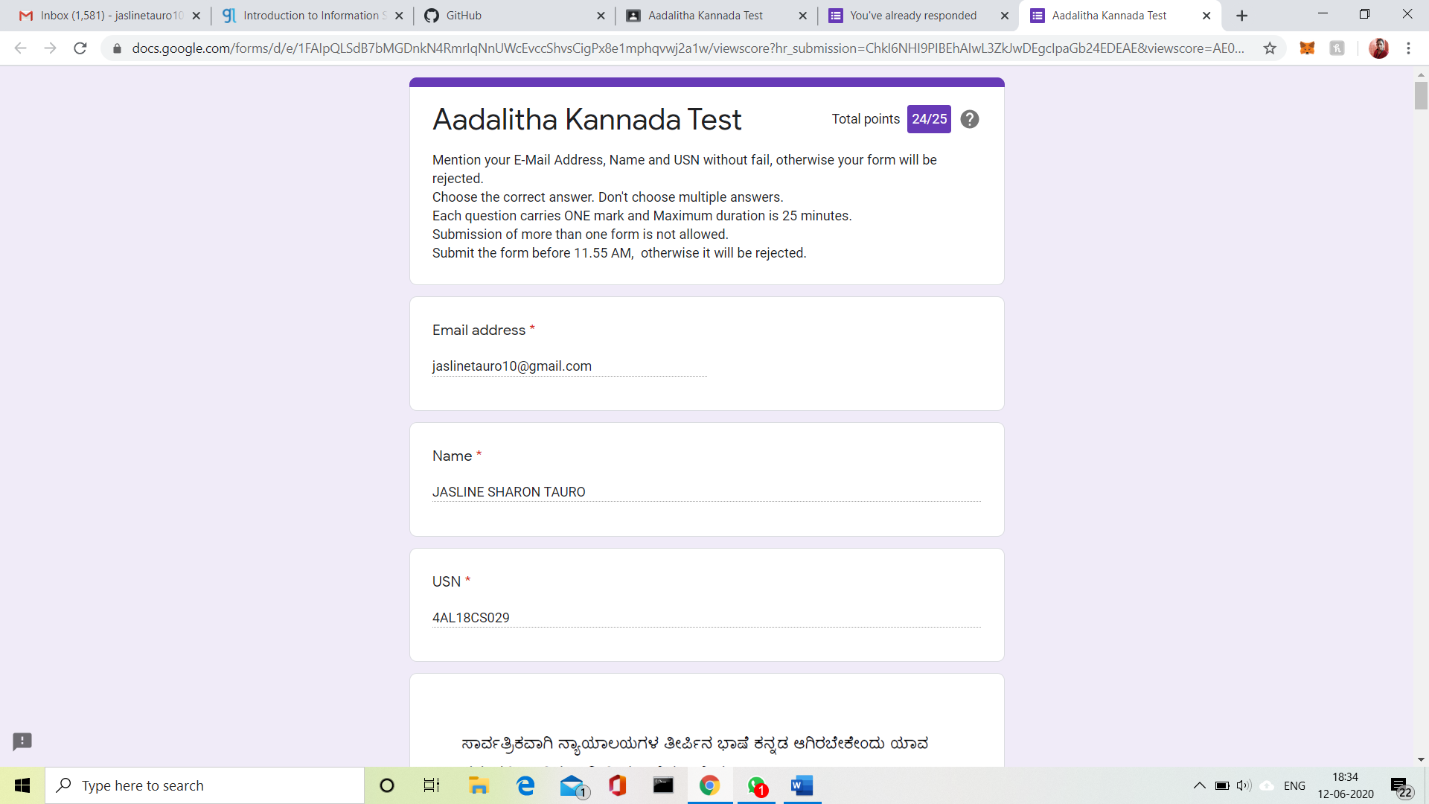

2.CERTIFICATION COURSE DETAILS:

Today I have completed the course Introduction to Information Technology. I have learnt about SQL injection, Client-server platform and about various listing techniques like white listing and bad listing. Also learnt about password security and its different means.

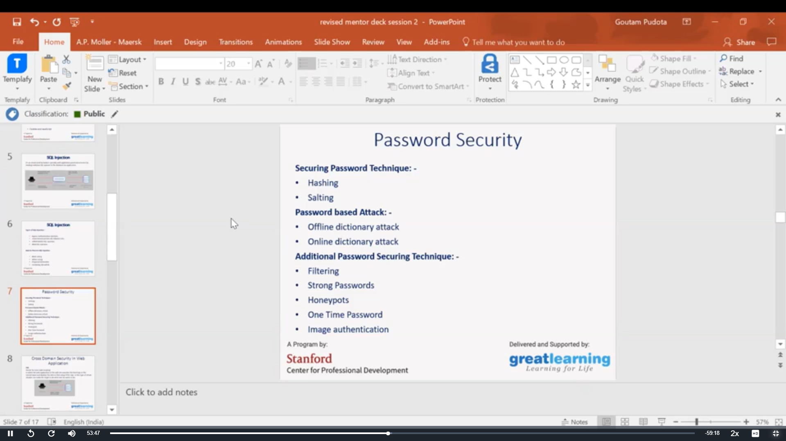

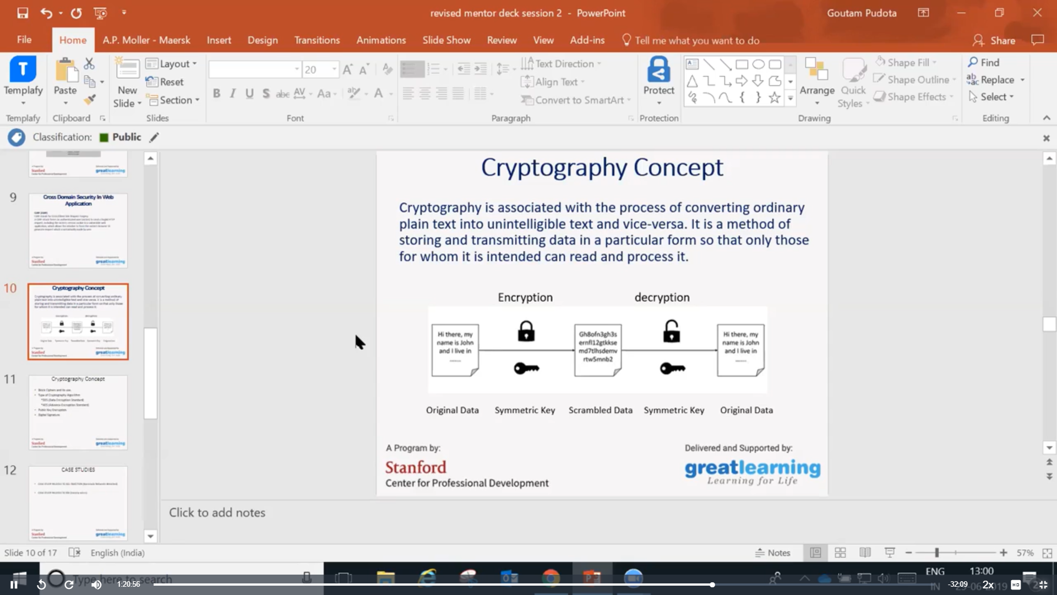

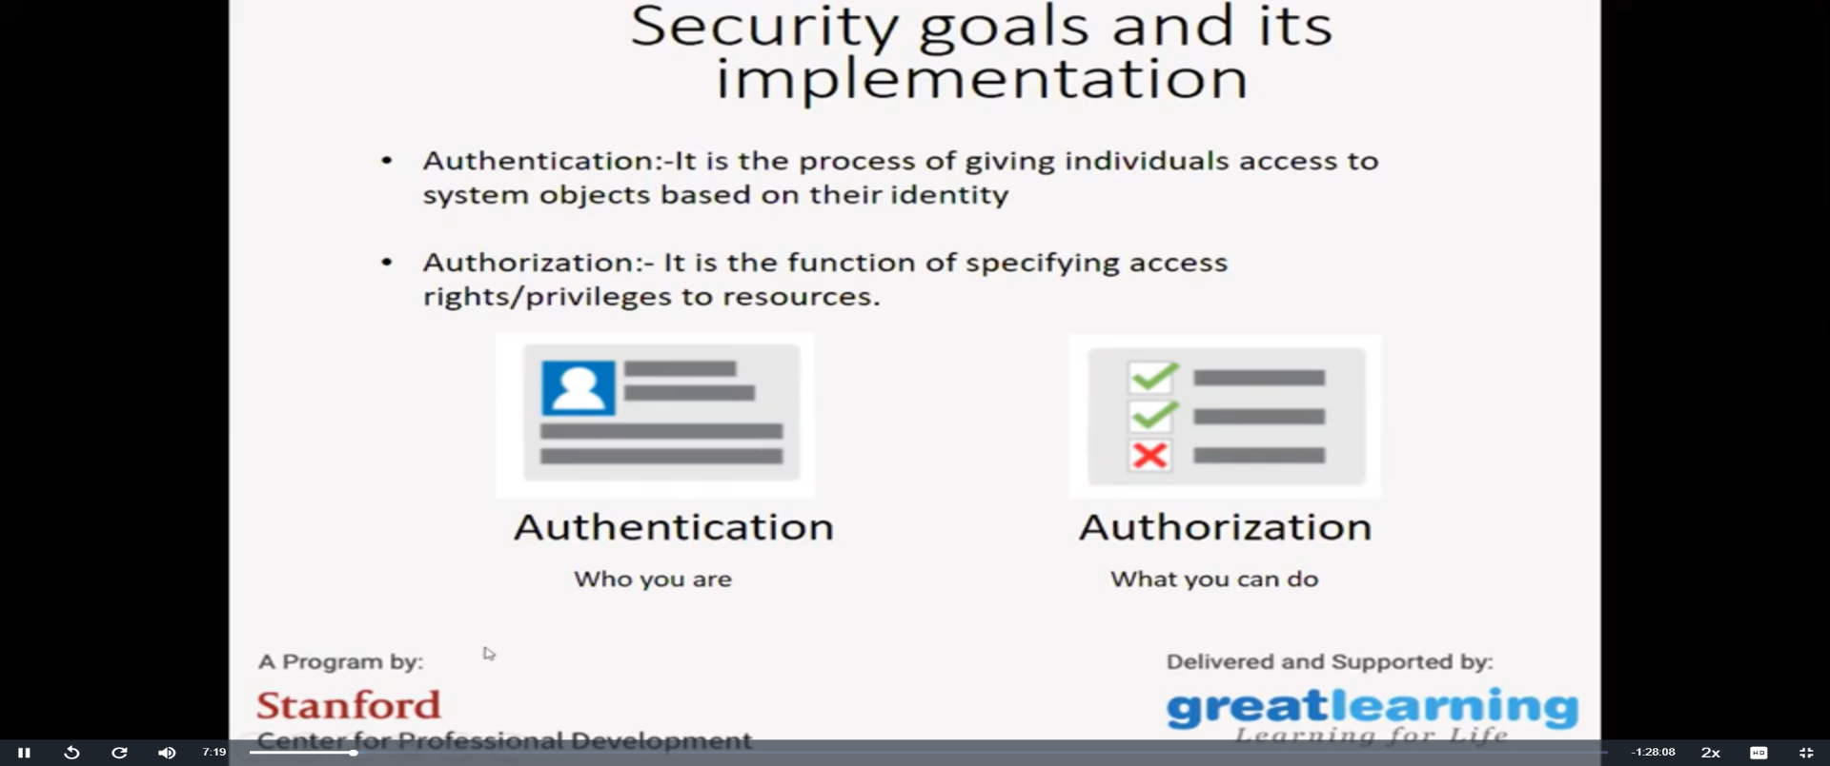

3.CODING CHALLENGES:

Problem Statement 1:

 Given two positive integers start and end. The task is to write a Python program to print all Prime numbers in an Interval.

Explanation: A prime number is a natural number greater than 1 that has no positive divisors other than 1 and itself. The first few prime numbers are {2, 3, 5, 7, 11, ….}. The idea to solve this problem is to iterate the val from start to end using a for loop and for every number, if it is greater than 1, check if it divides n. If we find any other number which divides, print that value.

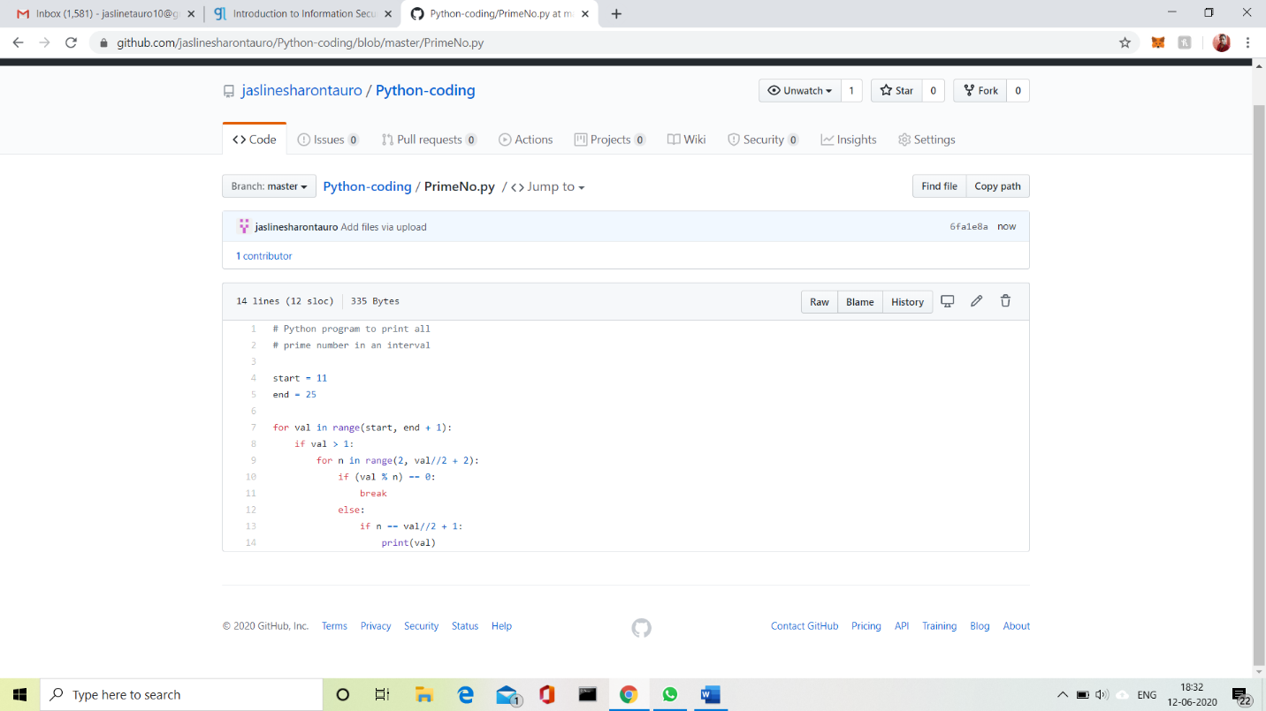Solution uploaded in GitHub.

Problem Statement 2:

Given an array of N elements and an integer M. Now, the array is modified by replacing some of the array elements with -1. The task is to print the original array. The elements in the original array are related as, for every index i, a[i] = (a[i-1]+1)% M. It is guaranteed that there is one non zero value in the array.

Examples:  
Input: arr[] = {5, -1, -1, 1, 2, 3}, M = 7  
Output: 5 6 0 1 2 3  
M = 7, so value at index 2 should be (5+1) % 7 = 6  
value at index 3 should be (6+1) % 7 = 0

Input: arr[] = {5, -1, 7, -1, 9, 0}, M = 10  
Output: 5 6 7 8 9 0  
Recommended: Please try your approach on {IDE} first, before moving on to the solution.  
Approach: First find the index of the non-negative value index i. Then simply go in two directions i.e. From i-1 to 0 and i+1 to n.

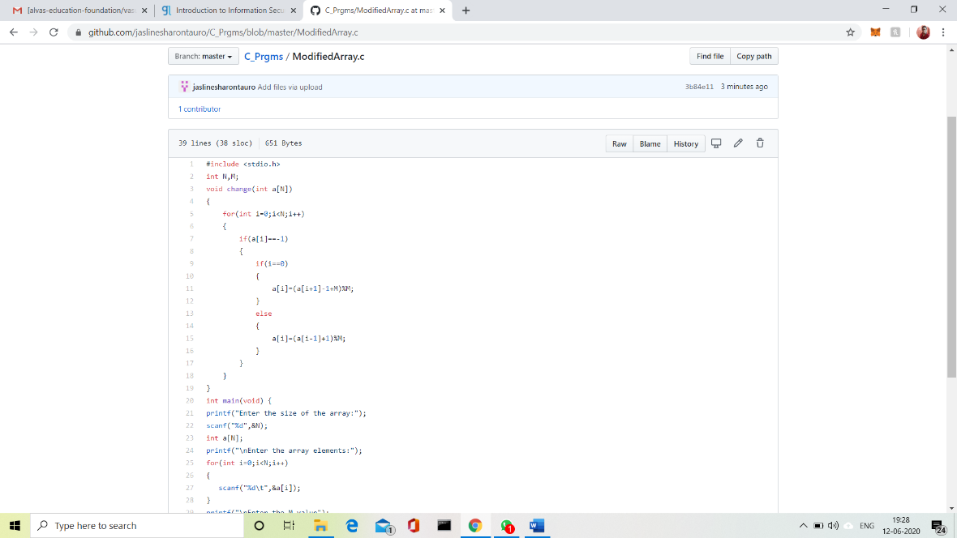For index i-1 the value can be calculated by (a[i+1]-1+m)%m because (a – b) mod p = ((a mod p – b mod p) + p) mod p.  
For indexes i+1 the values can be calculated by (a[i-1]+1)%m.

Solution uploaded in GitHub.